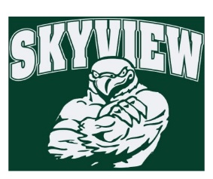
10.8.17 Edition
HAWK HAPPENINGS

Thanks to all the families who were able to join us for Skyview’s first Spirit Night. The event sold out. It was a great night for all!! Do not miss SPLASH Night in October!
Book Fair –Volunteers still needed, especially during 8th period. Sign-up at: http://signup.com/go/EhrUTZC
First Friday’s –Starting November 3rd. Join Skyview staff and wear Skyview spirit wear the first Friday of every month to show your school spirit! Skyview apparel is available for purchase at yourstartinglineup.com. A portion of all sales benefits Home & School! Items can be delivered free of charge to school or to your home for a small fee. All items can be customized with a school logo, your name, and more.
Skyview Bowling Club – We had a great turn-out our first week. There are a couple spots remaining for anyone interested in joining. Please contact Skyviewhomeandschool@gmail.com.
Skyview Spirit Night – Flyers were sent home last week. Join us on Saturday, October 21st 6:30-8:30pm for SPLASH Night/parent night out event. This event will sell out and is on a first come-first serve basis. Be sure to send in your payment with registration to reserve your spot.
Dine Out Night – Buffalo Wild Wings is supporting Skyview for the entire month of October. Must show flyer on phone or print. Be sure to order your wings for the football games!!
District Calendar – School is open Monday, October 9.
Directory – Orders are due October 9th.
Coin Drive – Has concluded. Thanks to everyone’s generosity, we collected over $500 to support the efforts of the Red Cross to help hurricane victims. In addition, some classes wrote sympathy cards that are being sent as well. Thank you for your kindness!
COMING NEXT WEEK
Boxtops – Collections begin October 16 and run through October 27. There is a collection bin in the main lobby outside the office. Be sure to label you bag with student and teacher name. The winning class will win a class snack (all allergies are accounted for).

